

Abdirizak Jarso Abdi

670233

Assignment: Area of a shape

United states international university

**PYTHON**

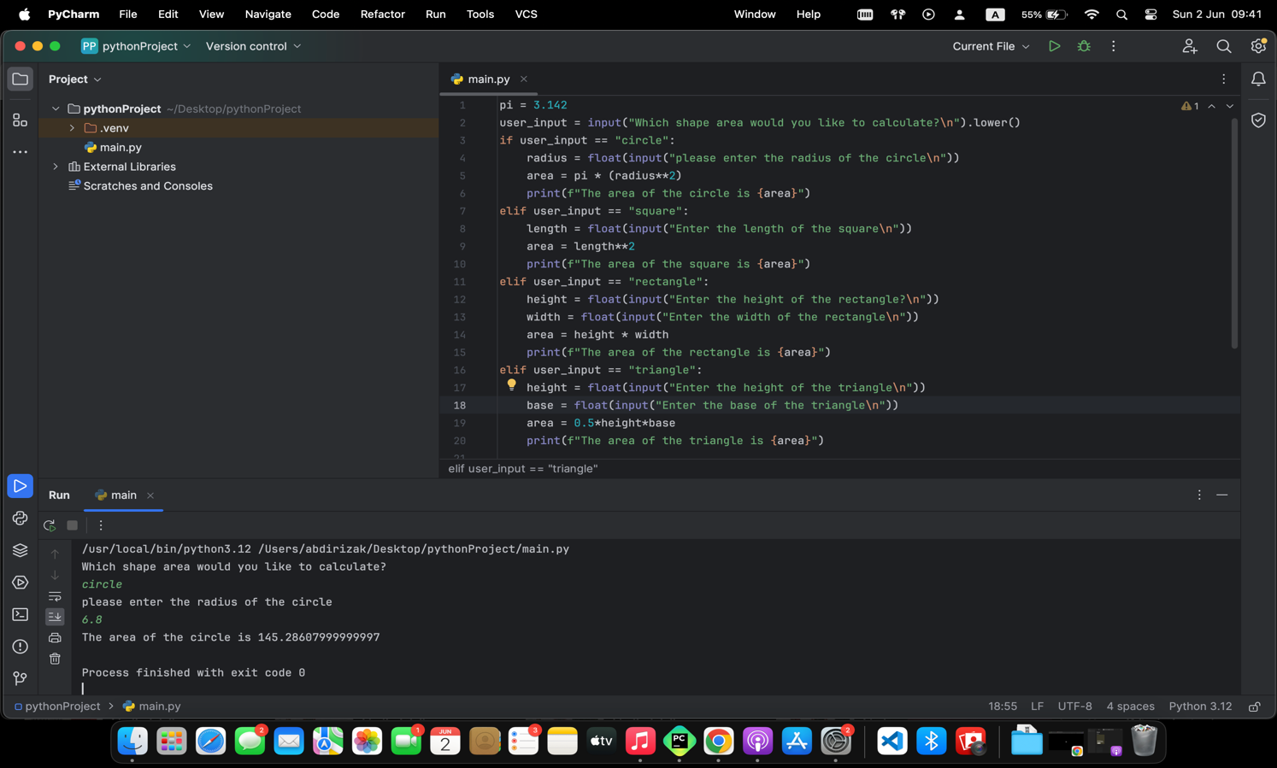

**C#**

[**https://www.programiz.com/online-compiler/593IFyhgJifss**](https://www.programiz.com/online-compiler/593IFyhgJifss)

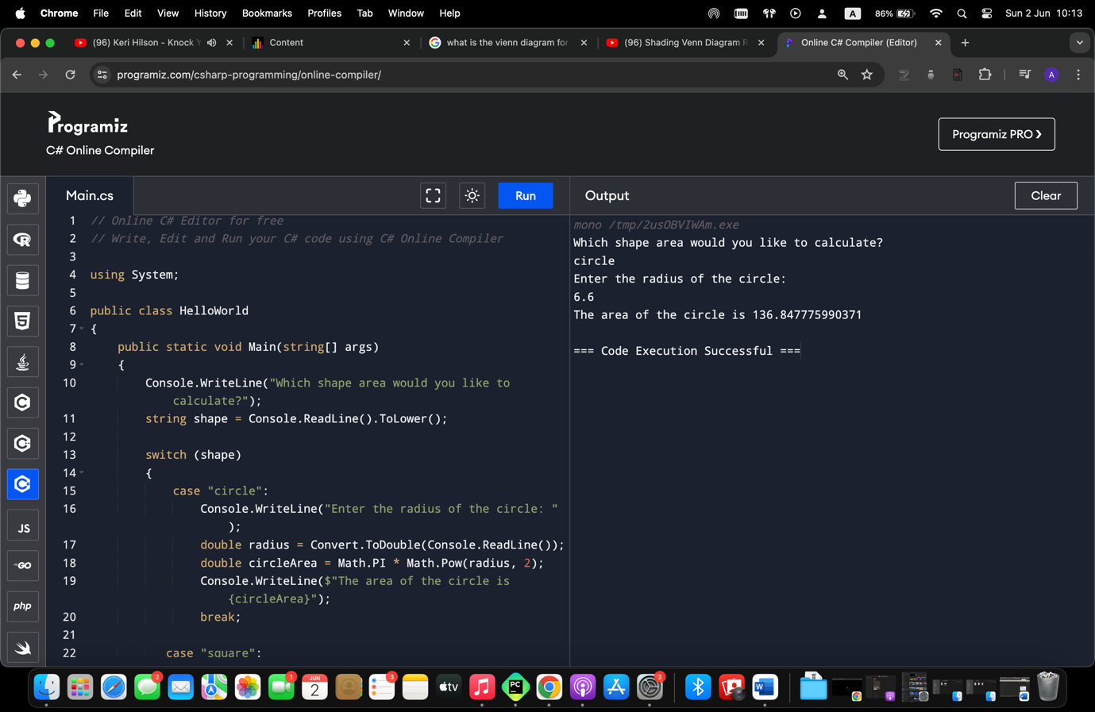

**JAVASCRIPT**

[**https://www.programiz.com/online-compiler/9iJb9yVmaPDgR**](https://www.programiz.com/online-compiler/9iJb9yVmaPDgR)

